**[Image Filtering](https://cs50.harvard.edu/x/2020/psets/4/filter/more/" \l "image-filtering)**

What does it even mean to filter an image? You can think of filtering an image as taking the pixels of some original image, and modifying each pixel in such a way that a particular effect is apparent in the resulting image.

[**Grayscale**](https://cs50.harvard.edu/x/2020/psets/4/filter/more/#grayscale)

One common filter is the “grayscale” filter, where we take an image and want to convert it to black-and-white. How does that work?

Recall that if the red, green, and blue values are all set to 0x00 (hexadecimal for 0), then the pixel is black. And if all values are set to 0xff (hexadecimal for 255), then the pixel is white. So long as the red, green, and blue values are all equal, the result will be varying shades of gray along the black-white spectrum, with higher values meaning lighter shades (closer to white) and lower values meaning darker shades (closer to black).

So to convert a pixel to grayscale, we just need to make sure the red, green, and blue values are all the same value. But how do we know what value to make them? Well, it’s probably reasonable to expect that if the original red, green, and blue values were all pretty high, then the new value should also be pretty high. And if the original values were all low, then the new value should also be low.

In fact, to ensure each pixel of the new image still has the same general brightness or darkness as the old image, we can take the average of the red, green, and blue values to determine what shade of grey to make the new pixel.

If you apply that to each pixel in the image, the result will be an image converted to grayscale.

[**Reflection**](https://cs50.harvard.edu/x/2020/psets/4/filter/more/#reflection)

Some filters might also move pixels around. Reflecting an image, for example, is a filter where the resulting image is what you would get by placing the original image in front of a mirror. So any pixels on the left side of the image should end up on the right, and vice versa.

Note that all of the original pixels of the original image will still be present in the reflected image, it’s just that those pixels may have rearranged to be in a different place in the image.

[**Blur**](https://cs50.harvard.edu/x/2020/psets/4/filter/more/#blur)

There are a number of ways to create the effect of blurring or softening an image. For this problem, we’ll use the “box blur,” which works by taking each pixel and, for each color value, giving it a new value by averaging the color values of neighboring pixels.

Consider the following grid of pixels, where we’ve numbered each pixel.

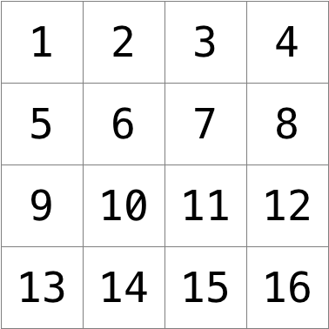

The new value of each pixel would be the average of the values of all of the pixels that are within 1 row and column of the original pixel (forming a 3x3 box). For example, each of the color values for pixel 6 would be obtained by averaging the original color values of pixels 1, 2, 3, 5, 6, 7, 9, 10, and 11 (note that pixel 6 itself is included in the average). Likewise, the color values for pixel 11 would be be obtained by averaging the color values of pixels 6, 7, 8, 10, 11, 12, 14, 15 and 16.

For a pixel along the edge or corner, like pixel 15, we would still look for all pixels within 1 row and column: in this case, pixels 10, 11, 12, 14, 15, and 16.

#### [Edges](https://cs50.harvard.edu/x/2020/psets/4/filter/more/#edges)

In artificial intelligence algorithms for image processing, it is often useful to detect edges in an image: lines in the image that create a boundary between one object and another. One way to achieve this effect is by applying the [Sobel operator](https://en.wikipedia.org/wiki/Sobel_operator) to the image.

Like image blurring, edge detection also works by taking each pixel, and modifying it based on the 3x3 grid of pixels that surrounds that pixel. But instead of just taking the average of the nine pixels, the Sobel operator computes the new value of each pixel by taking a weighted sum of the values for the surrounding pixels. And since edges between objects could take place in both a vertical and a horizontal direction, you’ll actually compute two weighted sums: one for detecting edges in the x direction, and one for detecting edges in the y direction. In particular, you’ll use the following two “kernels”:

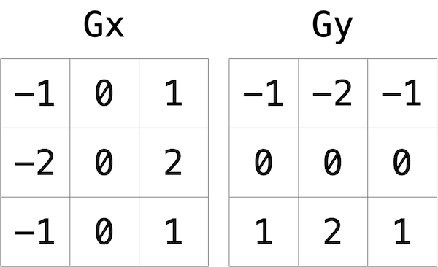

How to interpret these kernels? In short, for each of the three color values for each pixel, we’ll compute two values Gx and Gy. To compute Gx for the red channel value of a pixel, for instance, we’ll take the original red values for the nine pixels that form a 3x3 box around the pixel, multiply them each by the corresponding value in the Gx kernel, and take the sum of the resulting values.

Why these particular values for the kernel? In the Gx direction, for instance, we’re multiplying the pixels to the right of the target pixel by a positive number, and multiplying the pixels to the left of the target pixel by a negative number. When we take the sum, if the pixels on the right are a similar color to the pixels on the left, the result will be close to 0 (the numbers cancel out). But if the pixels on the right are very different from the pixels on the left, then the resulting value will be very positive or very negative, indicating a change in color that likely is the result of a boundary between objects. And a similar argument holds true for calculating edges in the y direction.

Using these kernels, we can generate a Gx and Gy value for each of the red, green, and blue channels for a pixel. But each channel can only take on one value, not two: so we need some way to combine Gx and Gy into a single value. The Sobel filter algorithm combines Gx and Gy into a final value by calculating the square root of Gx^2 + Gy^2. And since channel values can only take on integer values from 0 to 255, be sure the resulting value is rounded to the nearest integer and capped at 255!

And what about handling pixels at the edge, or in the corner of the image? There are many ways to handle pixels at the edge, but for the purposes of this problem, we’ll ask you to treat the image as if there was a 1 pixel solid black border around the edge of the image: therefore, trying to access a pixel past the edge of the image should be treated as a solid black pixel (values of 0 for each of red, green, and blue). This will effectively ignore those pixels from our calculations of Gx and Gy.

## [Understanding](https://cs50.harvard.edu/x/2020/psets/4/filter/more/#understanding)

Let’s now take a look at some of the files provided to you as distribution code to get an understanding for what’s inside of them.

### [bmp.h](https://cs50.harvard.edu/x/2020/psets/4/filter/more/#bmph)

Open up bmp.h (as by double-clicking on it in the file browser) and have a look.

You’ll see definitions of the headers we’ve mentioned (BITMAPINFOHEADER and BITMAPFILEHEADER). In addition, that file defines BYTE, DWORD, LONG, and WORD, data types normally found in the world of Windows programming. Notice how they’re just aliases for primitives with which you are (hopefully) already familiar. It appears that BITMAPFILEHEADER and BITMAPINFOHEADER make use of these types.

Perhaps most importantly for you, this file also defines a struct called RGBTRIPLE that, quite simply, “encapsulates” three bytes: one blue, one green, and one red (the order, recall, in which we expect to find RGB triples actually on disk).

Why are these structs useful? Well, recall that a file is just a sequence of bytes (or, ultimately, bits) on disk. But those bytes are generally ordered in such a way that the first few represent something, the next few represent something else, and so on. “File formats” exist because the world has standardized what bytes mean what. Now, we could just read a file from disk into RAM as one big array of bytes. And we could just remember that the byte at array[i] represents one thing, while the byte at array[j] represents another. But why not give some of those bytes names so that we can retrieve them from memory more easily? That’s precisely what the structs in bmp.h allow us to do. Rather than think of some file as one long sequence of bytes, we can instead think of it as a sequence of structs.

### [filter.c](https://cs50.harvard.edu/x/2020/psets/4/filter/more/#filterc)

Now, let’s open up filter.c. This file has been written already for you, but there are a couple important points worth noting here.

First, notice the definition of filters on line 11. That string tells the program what the allowable command-line arguments to the program are: b, e, g, and r. Each of them specifies a different filter that we might apply to our images: blur, edge detection, grayscale, and reflection.

The next several lines open up an image file, make sure it’s indeed a BMP file, and read all of the pixel information into a 2D array called image.

Scroll down to the switch statement that begins on line 102. Notice that, depending on what filter we’ve chosen, a different function is called: if the user chooses filter b, the program calls the blur function; if e, then edges is called; if g, then grayscale is called; and if r, then reflect is called. Notice, too, that each of these functions take as arguments the height of the image, the width of the image, and the 2D array of pixels.

These are the functions you’ll (soon!) implement. As you might imagine, the goal is for each of these functions to edit the 2D array of pixels in such a way that the desired filter is applied to the image.

The remaining lines of the program take the resulting image and write them out to a new image file.

### [helpers.h](https://cs50.harvard.edu/x/2020/psets/4/filter/more/#helpersh)

Next, take a look at helpers.h. This file is quite short, and just provides the function prototypes for the functions you saw earlier.

Here, take note of the fact that each function takes a 2D array called image as an argument, where image is an array of height many rows, and each row is itself another array of width many RGBTRIPLEs. So if image represents the whole picture, then image[0] represents the first row, and image[0][0] represents the pixel in the upper-left corner of the image.

### [helpers.c](https://cs50.harvard.edu/x/2020/psets/4/filter/more/#helpersc)

Now, open up helpers.c. Here’s where the implementation of the functions declared in helpers.h belong. But note that, right now, the implementations are missing! This part is up to you.

### [Makefile](https://cs50.harvard.edu/x/2020/psets/4/filter/more/#makefile)

Finally, let’s look at Makefile. This file specifies what should happen when we run a terminal command like make filter. Whereas programs you may have written before were confined to just one file, filter seems to use multiple files: filter.c, bmp.h, helpers.h, and helpers.c. So we’ll need to tell make how to compile this file.

Try compiling filter for yourself by going to your terminal and running

$ make filter

Then, you can run the program by running:

$ ./filter -g images/yard.bmp out.bmp

which takes the image at images/yard.bmp, and generates a new image called out.bmp after running the pixels through the grayscale function. grayscale doesn’t do anything just yet, though, so the output image should look the same as the original yard.

## [Specification](https://cs50.harvard.edu/x/2020/psets/4/filter/more/#specification)

Implement the functions in helpers.c such that a user can apply grayscale, reflection, blur, or edge detection filters to their images.

* The function grayscale should take an image and turn it into a black-and-white version of the same image.
* The reflect function should take an image and reflect it horizontally.
* The blur function should take an image and turn it into a box-blurred version of the same image.
* The edges function should take an image and highlight the edges between objects, according to the Sobel operator.

You should not modify any of the function signatures, nor should you modify any other files other than helpers.c.